PRACOVNÍ LIST

Přepište věty a podtržená jména nahraďte příslušnými zájmeny, tedy subject nebo object pronoun.
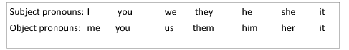

I visit my grandma every Wednesday. I visit her every Wednesday.

1. The boy listens to music. ___________________________________

2. The girl rides a bike every day. _______________________________

3. My mum can speak English. _________________________________

4. Rosy and Tim study Maths. __________________________________

5. My friends help me. ________________________________________

6. My dad can cook. __________________________________________

7. I visit my friends every Saturday. _______________________________

8. I visit my grandfather every Sunday. _____________________________

9. I write an email to my friends. __________________________________

10. We see Billy every day. _____________________________________

11. I see Janet every Monday. ___________________________________

12. He opens the door. _________________________________________

13. We like the classroom. ______________________________________

14. I go swimming with Jane and Tom every Saturday. ________________

_____________________________________________________________

15. I go swimming with my sister. _________________________________

