TREVOR TROLL

This is Trevor Troll. He is short, fat and green. He has got purple hair and big orange eyes.
His mouth is really big, but his teeth are small and yellow. He has got strong hairy arms with a tattoo of a red heart with the word MUMMY under it. He has got short legs and enormous feet. His toes are hairy and very dirty – so they are black. Trevor‘s nose and ears are really big and hairy too.
Today, it is his birthday and he is wearing his orange and black shorts and T- shirt. His cake is pink.
He very is happy.
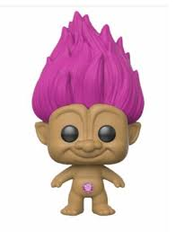
VOCABULARY:
TROLL
STRONG silný
HEART
ENORMOUS obrovský
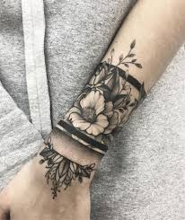
HAIRY chlupatý
DIRTY špinavý
WEARING má na sobě
TATTOO

1. Je-li věty správně, zakroužkuj T (=true, pravda), není-li správně, zakroužkuj F (=false, špatně)
Trevor is green. T F
He has got purple hair. T F
His eyes are small and orange. T F
His arms are strong and hairy. T F
He has got tattoo. T F
Trevor‘s feet are small. T F
It is Trevor‘s birthday today. T F
Trevor is a happy troll. T F

2. Nakresli Trevora a popros mamku nebo taťku, aby ho vyfotili a poslali na email, Whatsapp, děkuji.

Zdroj: Primary reading box by C. Nixon and M. Tomlinson, Cambridge University Press 2005, photocopiable
Zdroj: https://www.google.com/search?

