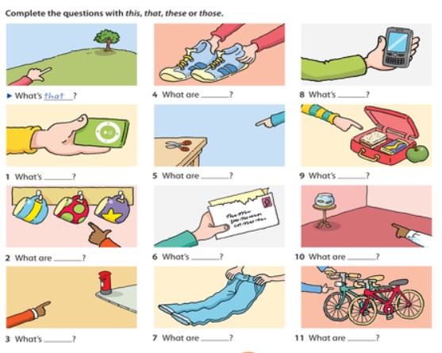
IS = THIS, THAT ARE=THESE, THOSE
- THIS
- THESE
- THAT
- THESE
- THOSE
- THIS
- THESE
- THIS
- THIS
- THOSE
- THESE

